**IP information:**

Client : 192.168.0.106

Server: 23.36.27.185

**A request packet:**  
  
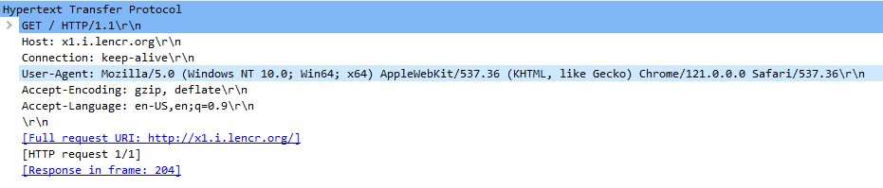

The client is looking for ‘x1.i.lencr.org’. Here the connection is persistent.

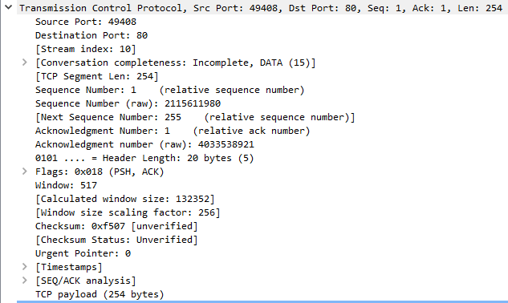

The client is requesting from 49408 source port to HTTP (80). Total length of the request is 254 bytes.

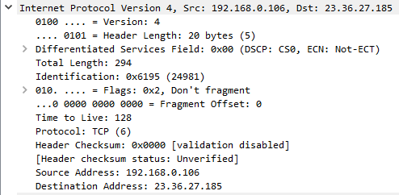

The IP version 4 is being used. The source is the client and the destination is the server.



The source and next hop device’s MAC address is provided in this layer.

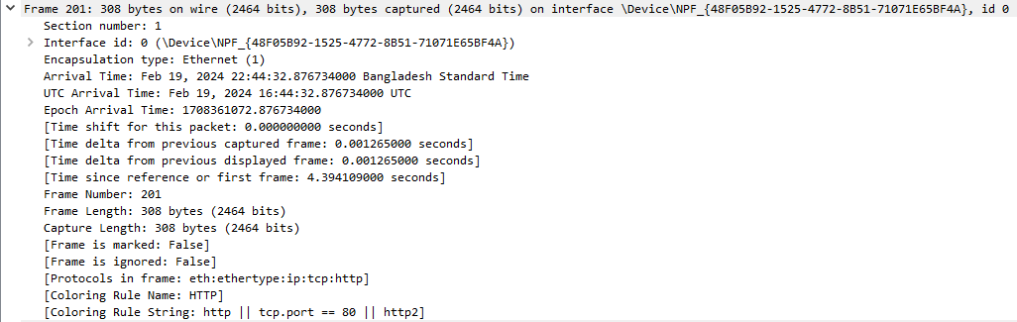

Finally the 308 bytes are being transferred through the wire.

**A response packet:**

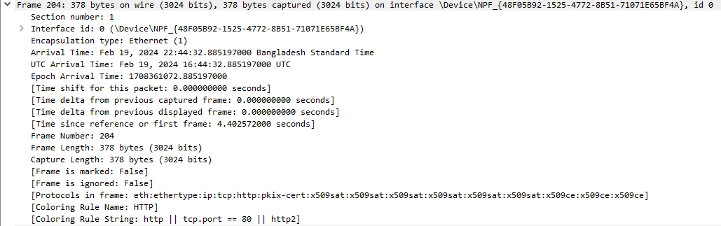

The response size is now 378 bytes in total. It came through the wire.



The destination MAC address is now the client and source is the client’s previous hop.

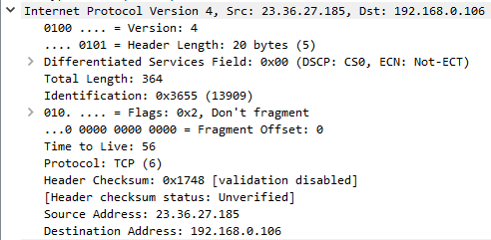

The destination IP address is now the client, and the source IP address is the server (since it is a response packet).

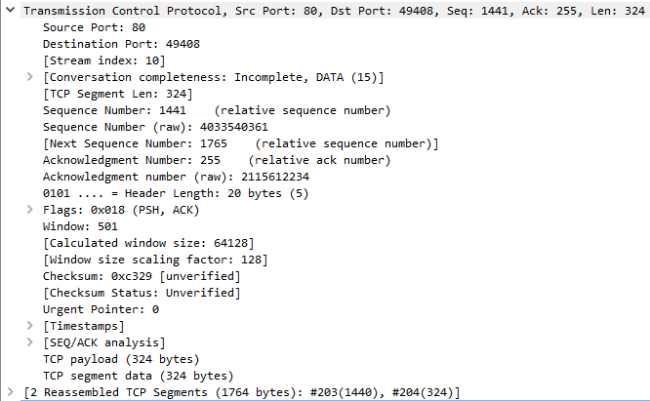

Port addressing is also the reverse as well.

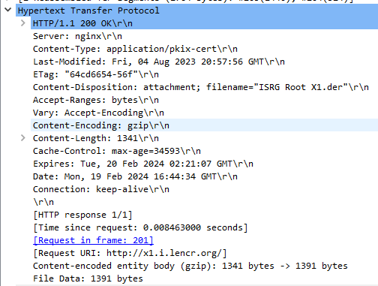

The HTTP response code is now 200, as the transmission is ok.

Content length is total 1341 bits

When the data was last modified and when will it expire is also given.

The transmission is persistent.